**Information System Management Lab**

**BCOM 307**

**Assignment #28**

***Submitted by:***

**Name:** YASH JAIN

**Enrollment No:** 03914788818

**Semester:** B.Com(H) 5TH Semester

**Class:** B.COM(H)

**Section:** B.Com 5A

**Date of Submission:** 14/11/2021

***Submitted to:***

**Praveen Kumar Singh**

**Assistant Professor, MAIMS**



**Department of Commerce**

**Maharaja Agrasen Institute of Management Studies**

**Affiliated to Guru Gobind Singh Indraprastha University, Delhi**

**Sector -22, Rohini, Delhi -110086, India; www.maims.ac.in**

Maharaja Agrasen Institute of Management Studies

Affiliated to GGS IP University; Recognized u/s 2(f) of UGC Recognized by Bar Council of India; ISO 9001: 2015

Certified Institution Sector 22, Rohini, Delhi -110086, India; [www.maims.ac.in](http://www.maims.ac.in/)

Department of Commerce

Academic Year: 2020-21

Semester: Vth

# Assignment No. 28

# Unit No:

**Course/Subject Code:** BCOM 307 **Subject Title: Information System Management Lab**

# Issue Date Last Date of Submission:

**Instructions for Students:**

# All Questions are Compulsory.

1. The student should attach proper cover page for each assignment clearly mentioning the Assignment No.
2. Each assignment should be prepared by the student individually with proper explaination and screenshots.
3. A4 size ruled sheets should be used for the assignment.
4. Assignment pages should be serially numbered at the bottom of page.

***During online education mode, upload scanned copy of the complete assignment including cover page latest by due date.***

|  |  |  |
| --- | --- | --- |
| **Question No.** | **Question** | **CO No.** |
| 1 | Print the description and total quantity sold for each product. | **CO2, CO3, CO4, CO5** |
| 2 | Find the non-moving products , i.e. products not sold. |
| 3 | Find the name and complete address for the customer who have placed order no. O19001. |
| 4 | Add a new column product rate in the table sales_order and update the values. |
| 5 | Find the names of clients who have placed order worth rs. 1000 or more. |

**ASSIGNMENT 28 - REVISION OF CONCEPTS II**

**Task 1 : Print the description and total quantity sold for each product.**

This task can be completed using the **LEFT JOIN** and the **GROUP BY** Clause.

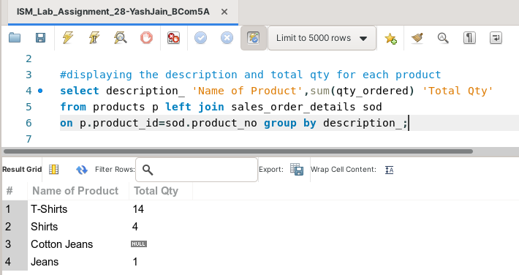

**Task 2: Find the non-moving products , i.e. products not sold.**

This task can be completed using the **NOT IN** Predicate, alongside **SQL Subquery**.

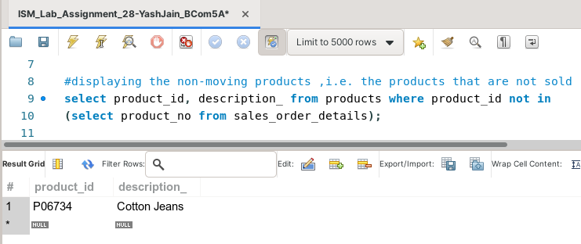

**Task 3: Find the name and complete address for the customer who have placed order no. O19001.**

This task can be completed using the **INNER JOIN** Clause, along with the **CONCAT( )** Function, which combines three columns of the table. The syntax for this is :

CONCAT ( string 1, separator, string 2, separator.....);

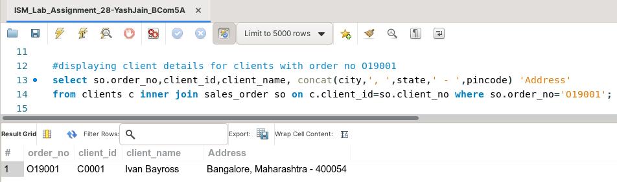

**Task 4: Add a new column product rate in the table sales_order and update the values.**

This task can be completed using the **ALTER TABLE** and the **UPDATE** Commands.

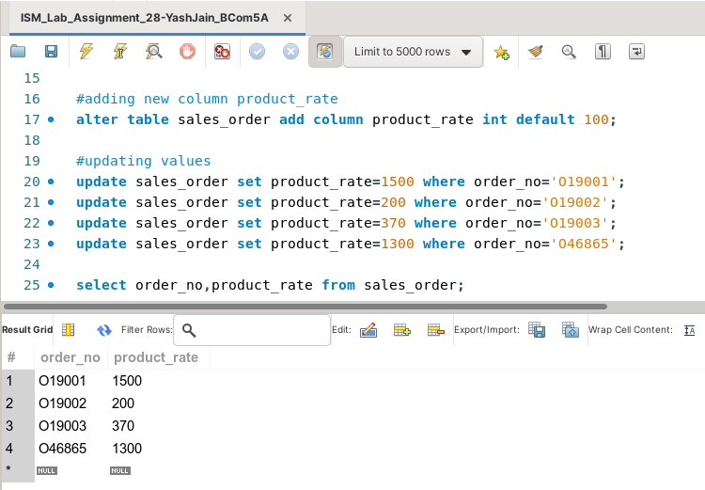

**Task 5: Find the names of clients who have placed order worth rs. 1000 or more.**

This task can be completed using the **INNER JOIN** Clause, along with the **GROUP BY** and the **HAVING** Clause.

